CSA0510 – DATABASE MANAGEMENT SYSTEM
SQL QUERIES TEST 3
Name : Poornima S
Reg.No.: 192521315

Create the two tables as shown below with the given constraints: (for questions 21 to 30) Table name: Employee
Constraints: Eid is Primary key and DeptId is foreign key Salary should not be less than 10000
Eid  (Primary Key) | Ename | DeptId  (Foreign Key) | Designation | Salary  ( > 10000) | DOJ
101 | Sudha | D2 | Clerk | 20000 | 01-Apr-10
102 | David | D1 | Manager | 50000 | 18-Feb-18
103 | Preethi | D3 | Clerk | 35000 | 13-Jun-11
104 | Kiran | D1 | Salesman | 20000 | 7-Mar-14
105 | Meenal | D2 | Clerk | 50000 | 9-Dec-11
106 | Sunitha | D3 | Manager | 60000 | 25-Sep-18
107 | Akhil | D3 | Clerk | 25000 | 14-Feb-16
108 | Sushma | D2 | Manager | 45000 | 31-Jan-12

Tablename: Department
Constraints:DeptId Primary key and Dname is NOT NULL

DeptId  (Primary Key) | Dname
D1 | Sales
D2 | Marketing
D3 | Finance

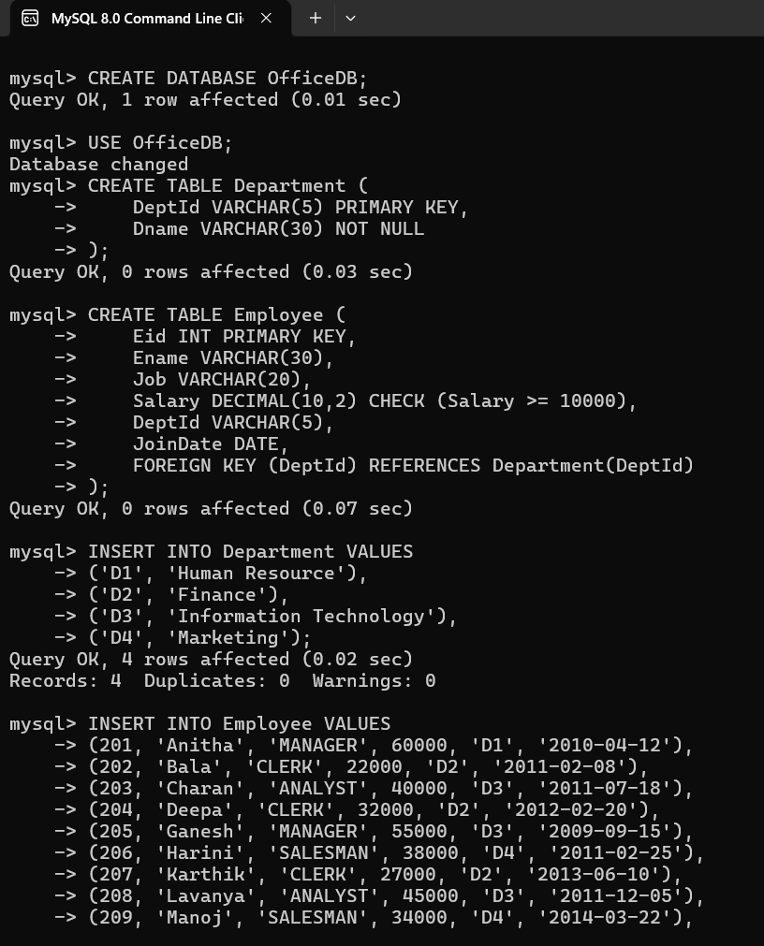

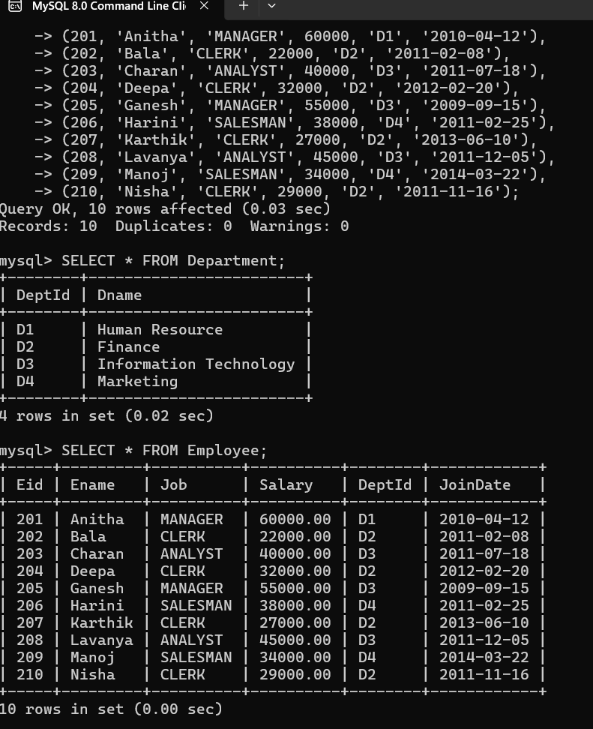

- Write sql query to display all the employees who earn more than average salary of all the employees in the company.

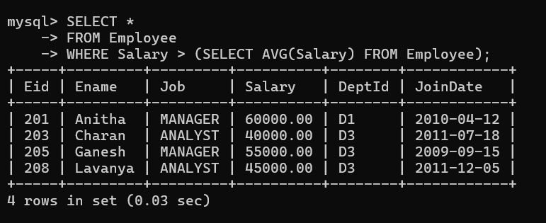

- Write sql query to display the fields Eid, Ename and Dname.

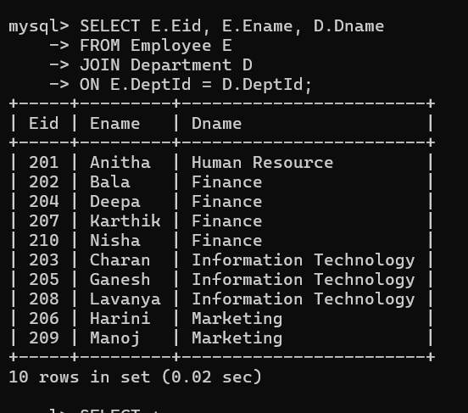

- Write sql query to sort the employee table in the descending order of salaries.

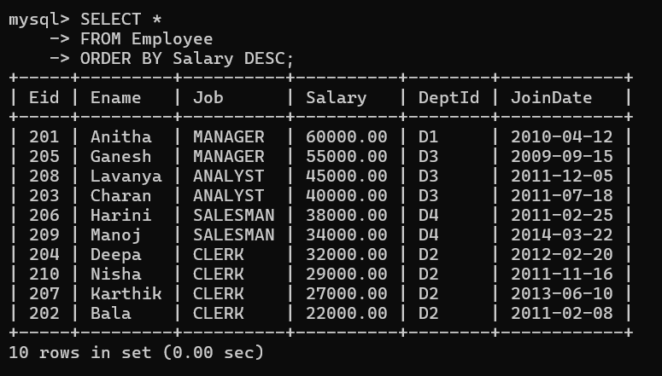

- Write sql query to list all the job designations in the employee table without repetitions.

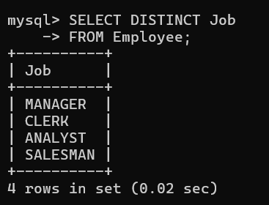

- Write sql query to display all the employee details Department wise and in the ascending order of their salaries.

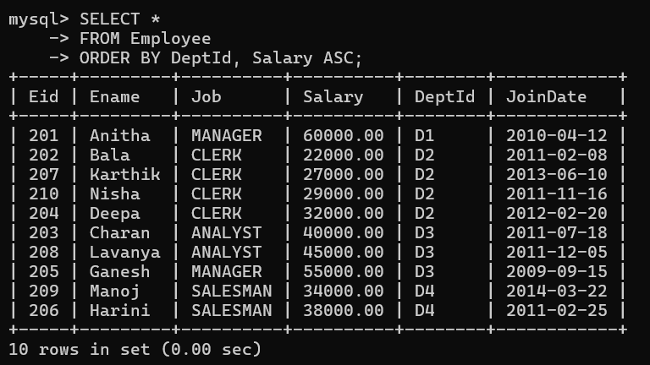

- Write sql query to display all the clerks in DeptId D2.

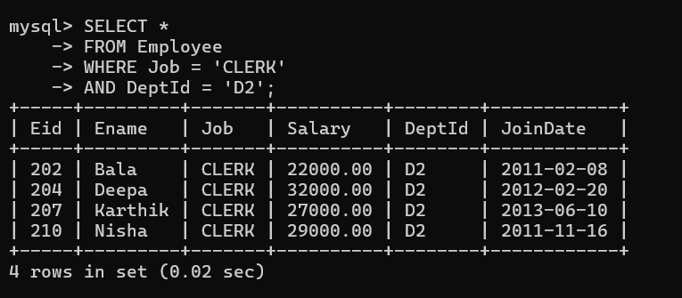

- Write sql query to display all the employees who joined in the year 2011.

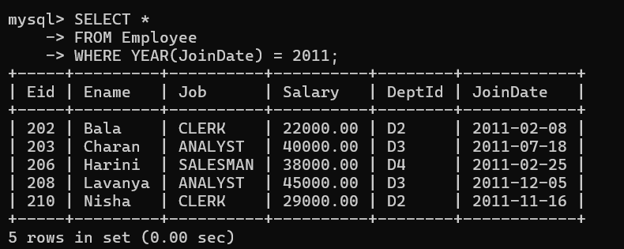

- Write sql query to display all the employees who joined in the month of February.

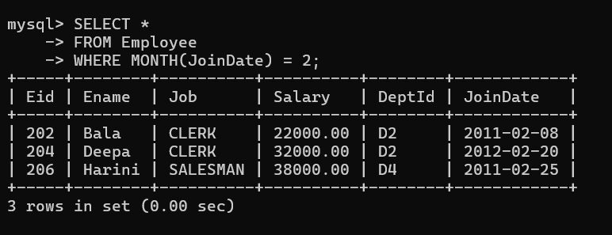

- Write sql query to display all the employees whose salary is between 30000 and 45000.

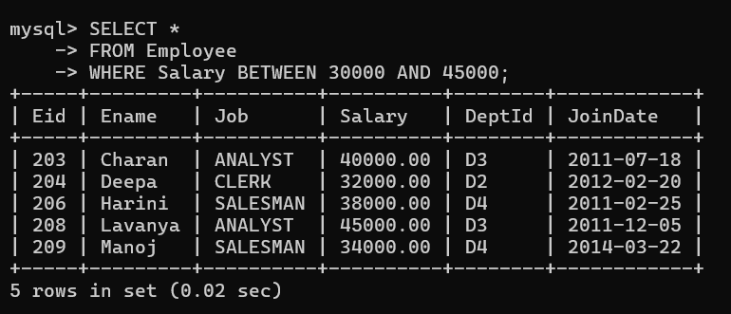

- Write sql query to display all the employee details along with their work experience in the company till current date.
